**User Guide for Calendar Application**

**Definition:**

The User Guide helps User in knowing the calendar application and its components for easy and effective usage.

**System Organization:**

The following features are implemented in the application:

* Views
  + Monthly View
  + Weekly View
  + Daily View
  + Agenda View
* Events
* Adding an Event
* Checking Time Conflict
* Edit and Delete Events
* Edit and Delete Event Categories
* Color marking for Event Categories
* Share
* Other

**VIEWS**

On opening the Calendar Application the default view is Month View. That can be changed using the drop down list present at the top left of the application. The drop down list contains 3 views (Monthly, Weekly, and Daily). Depending on the view selected the display of the calendar changes.

* **Monthly View:**

The following screenshot shows the default page of the calendar (Monthly view).

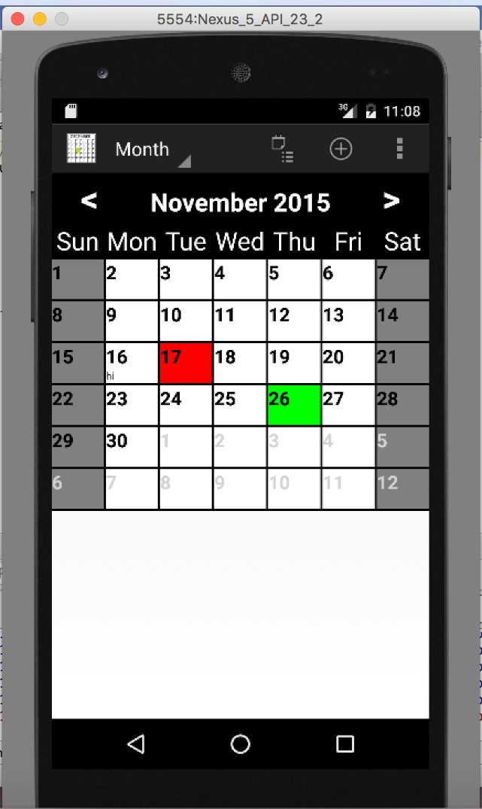

* **Weekly View**

Whenever Weekly view is selected in the drop down the following is displayed.

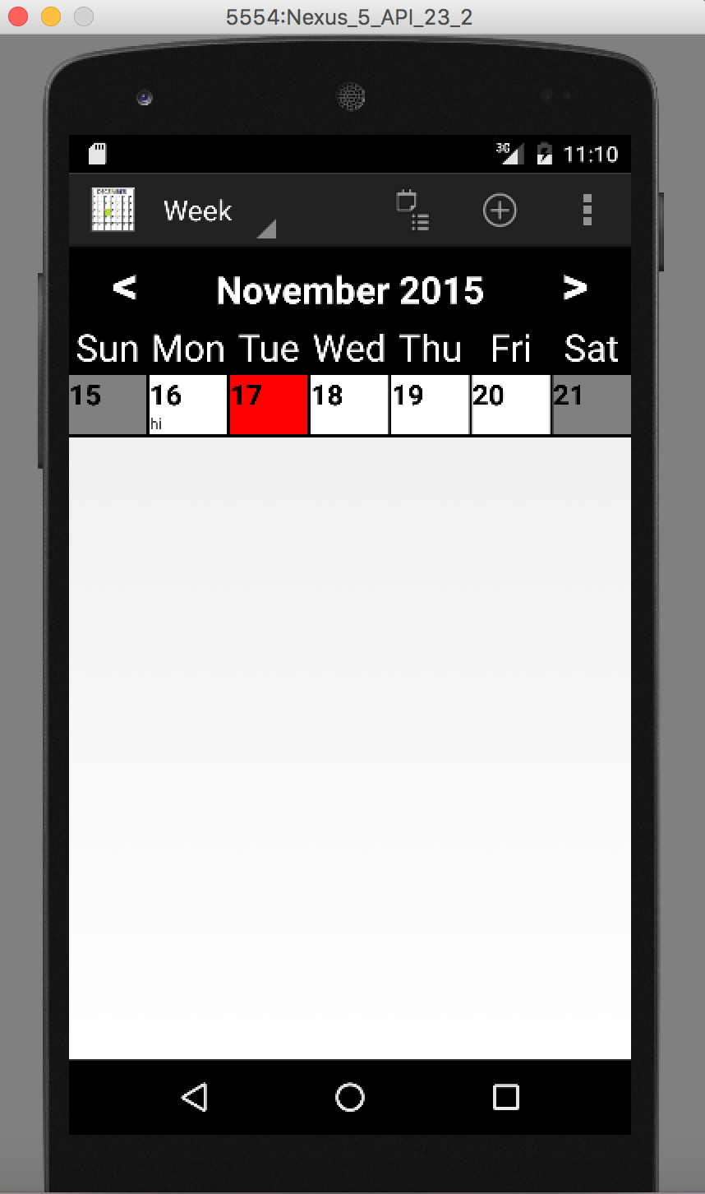

* **Daily View**

The Daily View is as following:

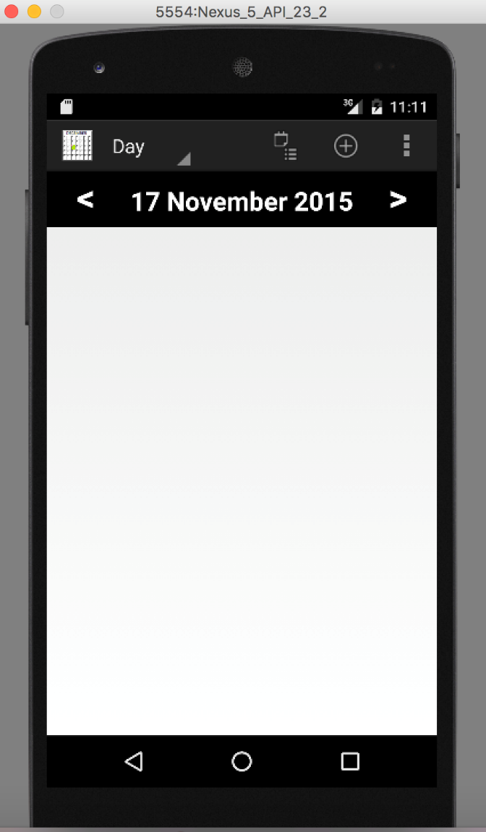

* **Agenda View**

Agenda view can be viewed by pressing the icon beside the drop down showing the views. Agenda view shows all the upcoming events stored in the calendar. Agenda view can only be seen if any events are present. If no event is present a pop shows up displaying Agenda view cannot be displayed as there are no evens to show. The following screenshot shows the Agenda view when events are present.

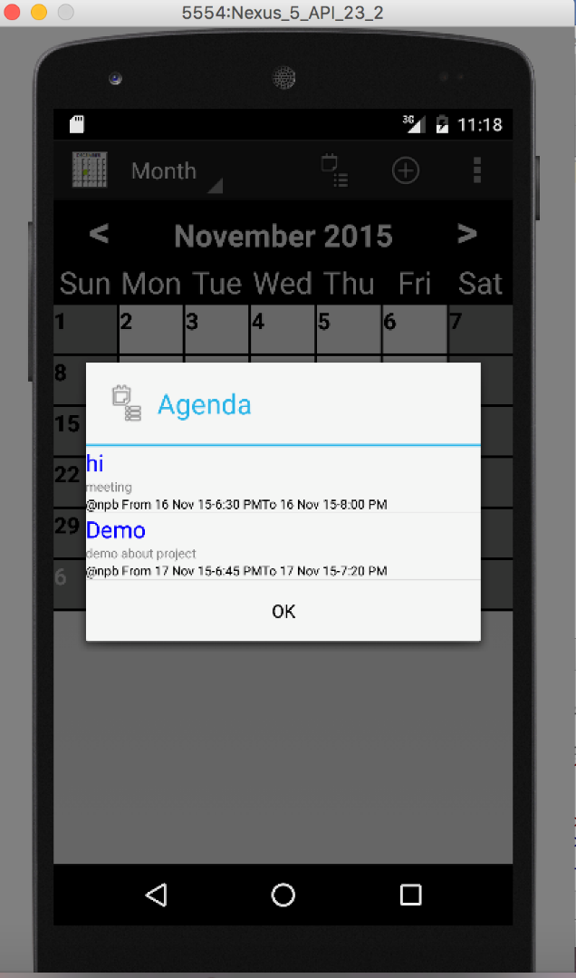

**EVENTS**

Events can be added into the Calendar. + Icon on the top right side of the application used to add the events to the calendar.

* **Adding an Event:**

For adding an event, event name, start and end dates with their respective times, event category, description about the event and location of the event are required. Event will fail to add if any of the fields are not present.

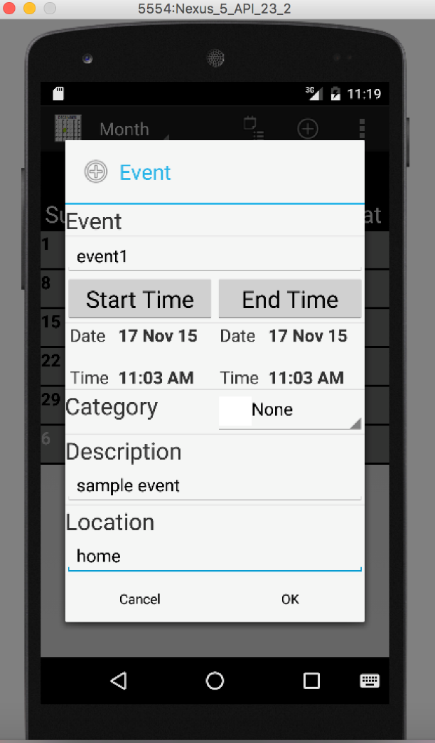

* **Checking Time Conflict:**

Event fails to add if two starts at same start time. If such a situation arises an error message pops up showing insertion failed. Event cannot be added if the start date or time is after the end date or time.

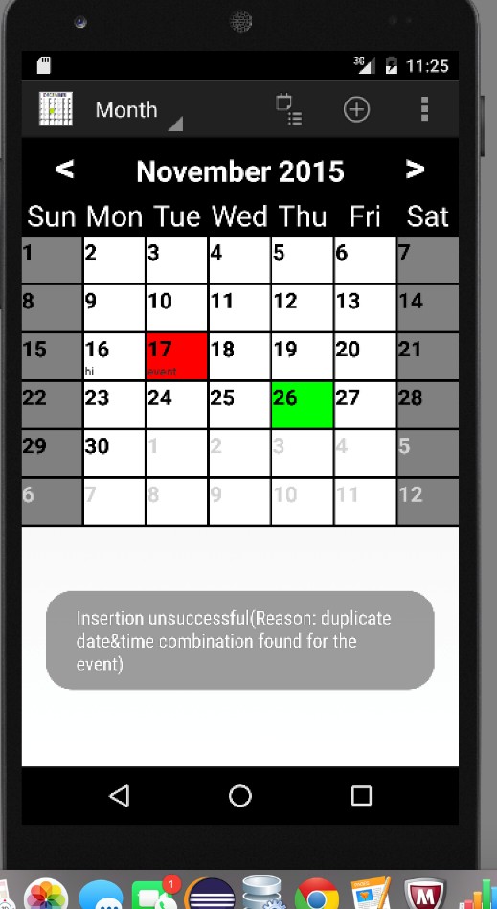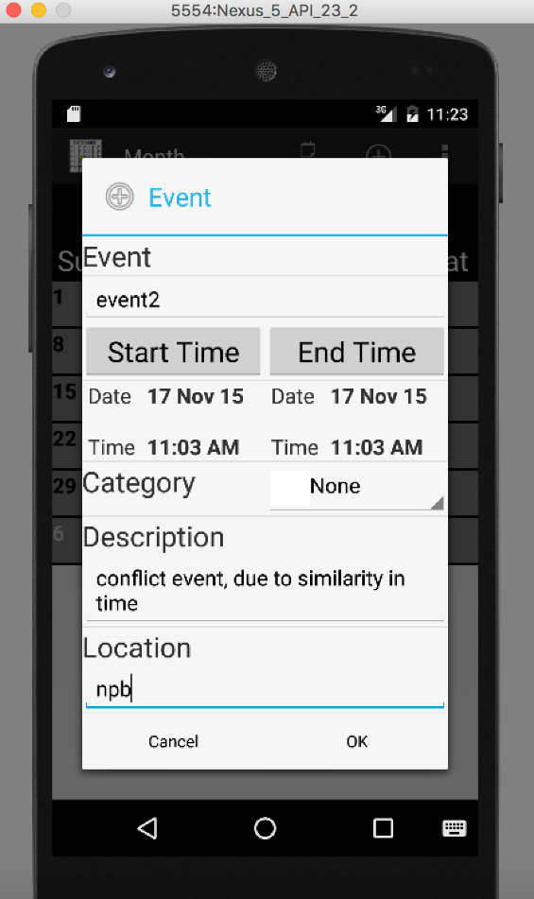

* **Edit and Delete Events:**

A particular event can be edited or deleted by using a long press on the event. On the long press, a dialogue pops up showing edit and delete options. On selecting the edit option, a dialogue similar to adding event shows up with the event details, necessary changes can be done here and after finishing click OK. On clicking OK another dialogue pops up asking to confirm the changes done to the event.

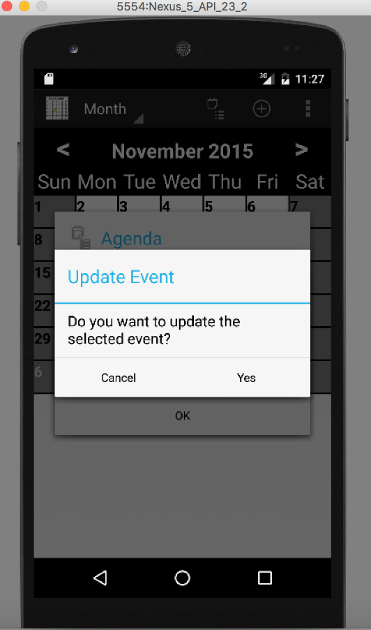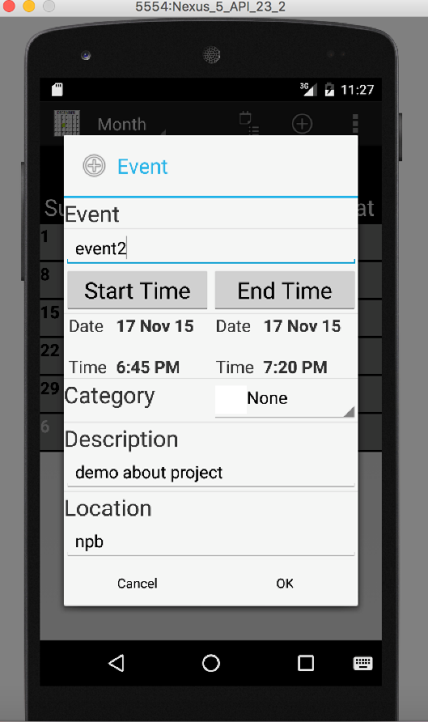

* **Adding an Event Category:**

Events can be separated into different categories depending on their types and the similar events can be grouped into a single category under a specific name and color differentiating them events of other types. This option is present in the top right of the application. There is an icon with 3 dots showing this option. On pressing the icon a dialogue with options i.e.; Add category and Settings appears.

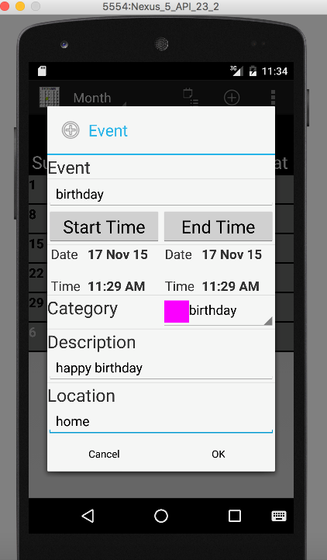

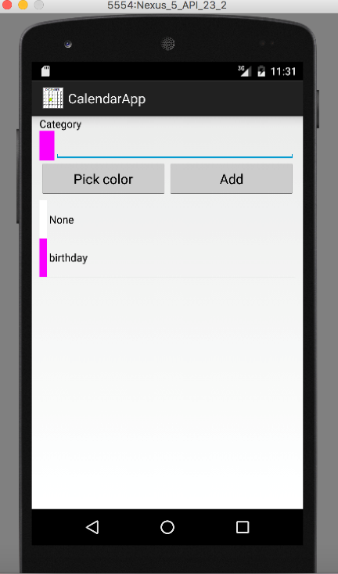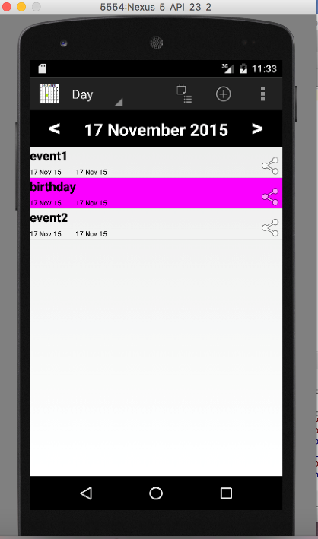

* **Color marking for Event Categories:**

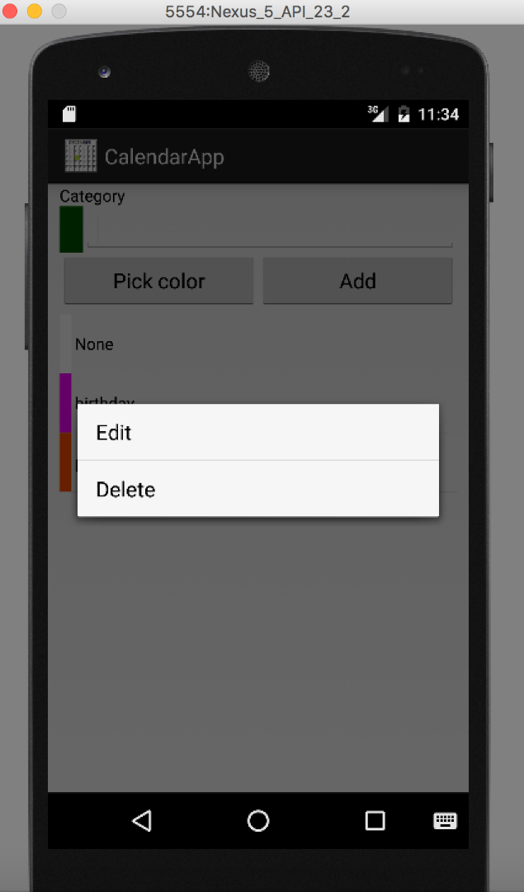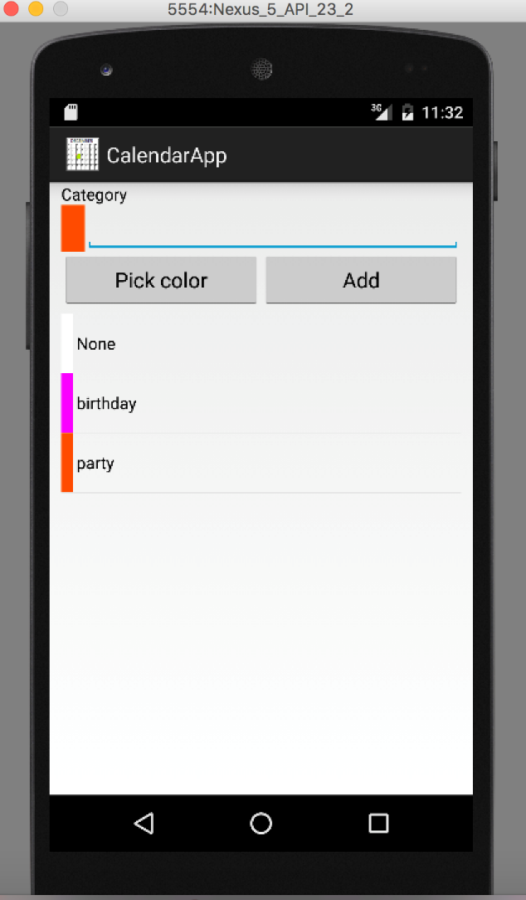You can pick a color and name for each category. These categories can edited or deleted by the user. For editing a category use a long press on the category to edit or delete it.

**SHARE:**

Allows the user to share the event with other users. Event is shared in the form of a link or text with other users over the internet. Checks whether the user has gained permission to share the event. Share option present for every event on the right side of the event. On pressing the share icon we get a list of options from which we can select the event.

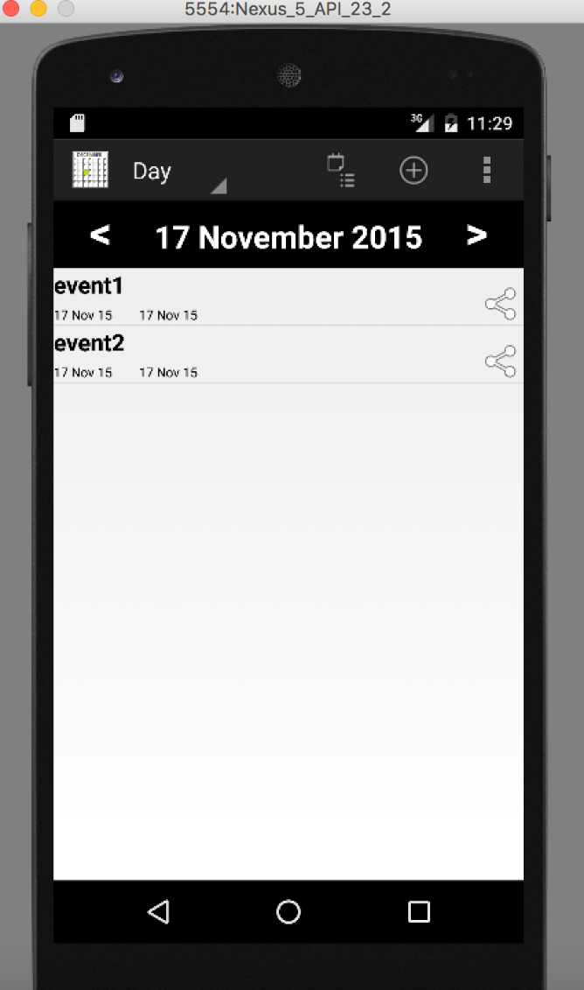

**OTHER**

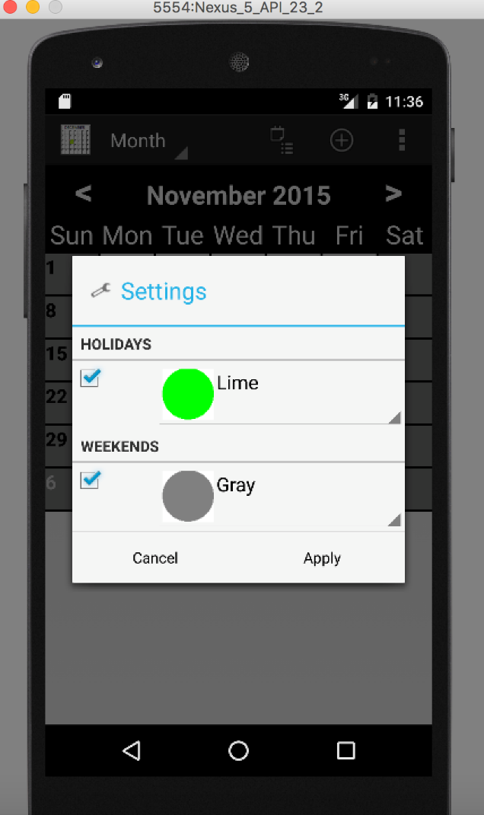Holidays and Weekends are differentiated using different colors. You can select this option from the settings. On selecting the settings option a dialogue with check boxes pertaining to holidays and weekends with their respective colors shows up. On enabling them all the weekends are shown in grey whereas the holidays are shown in lime color.

